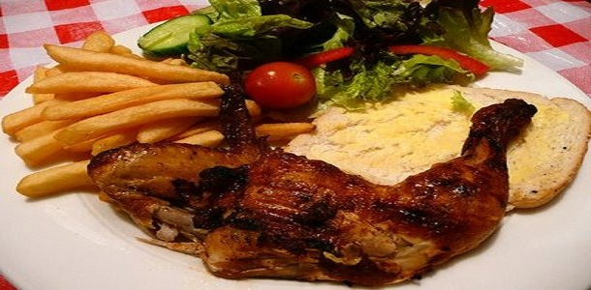

**Chicken in a Spicy Chilli Sauce**

* lemon Juice  6 tbsp
* Soya Sauce 2 Tbsp
* Salt  1 tsp
* Black Pepper half teaspoon
* Papprika 1 1/2Tbsp
* Garlic Paste 1 1/2 tsp
* Worshestershire Sauce 1 Tbsp
* Chinese salt 1/2 tsp
* Oil 2 Tbsp
* Meet tendrizer  1 tsp
* Hot Peri Peri Sauce  1 Tbsp

Method:

1. Marinate chicken pieces in the above ingredients for atleast 2 to 4 hours.
2. Preheat grill.
3. Grill chicken for half an hour on medium grill and then 15 more minutes on low heat.
4. Chicken should be tender and properly grilled before serving.

Note: Nando’s peri peri sauce is easily available from any galitos shop in Nairobi.